Third Announcement 4-2-12

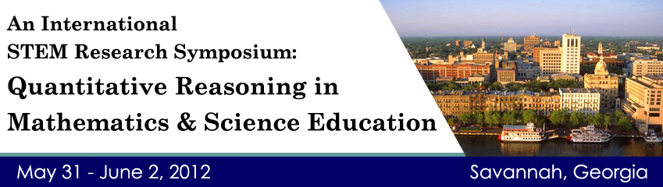

WISDOMe of the University of Wyoming, the NSF Pathways Project, a multiple university Mathematics and Science Partnership (MSP) housed at Colorado State University, and the Georgia Southern University Office of Research invite you to participate in the **International STEM Research Symposium**.

The symposium website, <http://coe.georgiasouthern.edu/QR/symposium.html> is now fully functional, including links for hotel information, travel information, online registration, and information about the symposium and Savannah.

This symposium is a continuation of efforts in WISDOMe to establish an active research collaborative focused on quantitative reasoning.  This effort has already spawned a research conference, working sessions at PME and NCTM, and a monograph on QR.  The symposium will incorporate four themes:

* + - Quantitative Reasoning (QR)
    - Mathematics as a Lived Experience (DIME)
    - Technology in Mathematics Teaching (TTAME)
    - Learning Progressions (LP)

The focus is on QR with discussions in the other three themes framed within QR.

**Research Working Groups**

National experts in each of the themes will lead research working groups by providing plenary talks and panel discussions, serving as expert advisors for working groups focused on the current state of research and establishing a future research agenda for the theme, and providing a conference paper to focus discussions on the theme.

**QR Experts**: **LP Experts**:  
Richard Duschl, Pennsylvania State University Arthur Baroody, University of Illinois  
Gail Jones, North Carolina State University Richard Lehrer, Vanderbilt University  
Bernard Madison, University of Arkansas Christina Schwarz, Michigan State  
Les Steffe, University of Georgia  
Pat Thompson, Arizona State University   
Please join us as a member of a working group, in which you will have the opportunity to share your work and collaborate with other researchers and practitioners in your area of interest.

**Symposium Chairs**

The three chairs of the symposium lead research and development efforts in the theme areas at the collaborating institutions.**Dr. Larry Hatfield** leads the WISDOMe Research Collaborative housed at the University of Wyoming, which brings research teams to the symposium in the areas of mathematics as lived experience, technology in teaching mathematics, and quantitative reasoning.  **Dr. John Moore** is PI of the NSF Pathways project which is leading efforts to develop learning progressions in the environmental sciences and exploring the role of quantitative reasoning in environmental science teaching.  **Dr. Robert Mayes** leads the WISDOMe Quantitative Reasoning team and is a Co-PI on the NSF Pathways project leading the Quantitative Reasoning theme.

**Registration Fee**

The conference fee is $150, which includes an opening dinner Thursday night, lunch Friday and Saturday, and an opportunity to work with national experts in the four symposium themes.  A social program Friday night will provide an opportunity for you to explore historic Savannah and the river district.  The Marriott Hotel is on the river in historic Savannah, with rooms at a special conference rate of $158 per night.  This is a working symposium so there are a limited number of spaces; reserve yours now.

**Join Us**

We hope that you can join us in beautiful Savannah, Georgia for professional collaboration and some southern hospitality.